ORDER FORM OFFICAL MERCHANDISE ISI WSC 2019
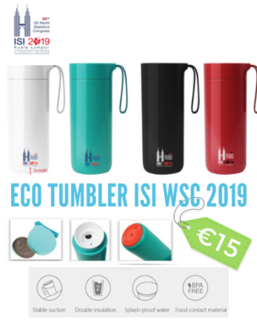 | Product details :  - Butterfly Vacuum Thermal Suction Flask/400ML  - Colour: White, Green, Black & Red  - Material: BPA Free/ Plastic  - Size: 203mm(H) x 72mm(D)  - Fits in car cup holders  - Suction base keeps it from falling over but lifts upright easily.
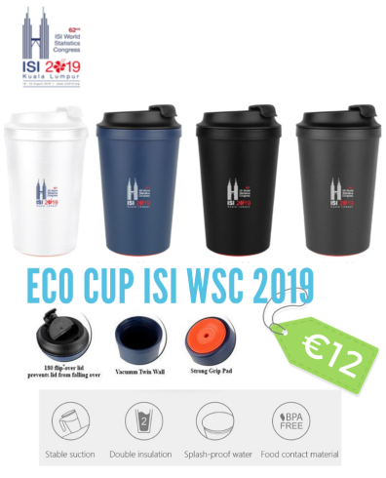 | Product details :  - Spirit-Double Wall Suction Cup/340ML  - Eco Tumbler Cup : White, Blue, Black & Grey  - Size: 146mm(H) x 85mm(D)  - Great as a reusable coffee cup for takeaways!  - Suction base keeps it from falling over but lifts upright easily.  - Stylish design and handy shape that is convenient for outdoor.
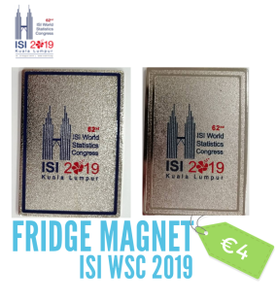 | Product details :  - F1 : Metal Fridge Magnet Blue  - F2 : Metal Fridge Magnet Silver  - Size: 8cm(H) x 5.5cm(W)
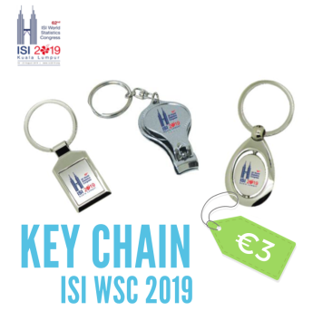 | Product details :  - K1 : Metal Key Chain Round  - K2 : Metal Key Chain Square  - K3 : Metal Nail Clipper

Product Detail | Quantity |  |  |  | TOTAL
Colour | Green | Black | White | Merah
Eco Tumbler
Colour | Grey | Black | White | Blue
Eco Cup
Colour | K1 | K2 | K3
Key Chain
Colour | F1 | F2
Fridge Magnet
TOTAL :

T-SHIRT ORDER FORM ISI WSC 2019
CODE : T01  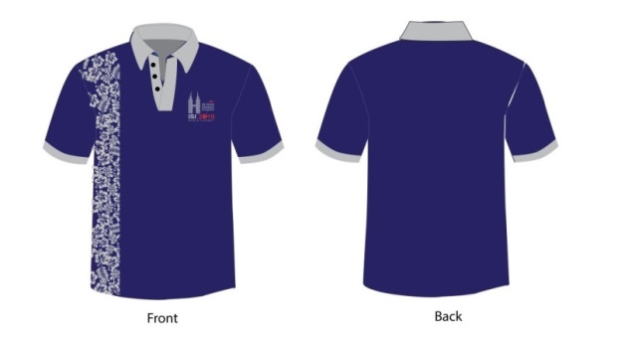 |  |  |  |  |  |  |  | CODE : T02  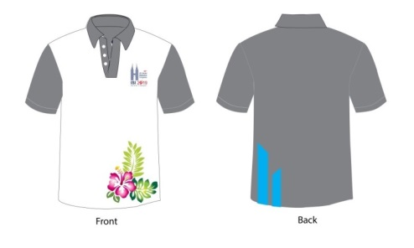
CODE : T03  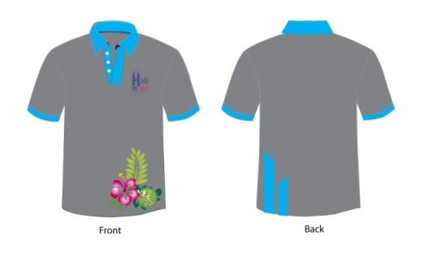 |  |  |  |  |  |  |  | CODE : T04  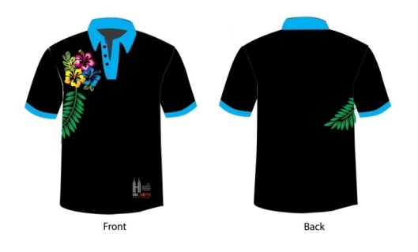
SIZE | QUANTITY |  |  |  |  |  |  | MYR |  | EURO |  | TOTAL
 | T01 |  |  | T02 | T03 | T04
S |  |  |  |  |  |  |  | 45 |  | 10
M |  |  |  |  |  |  |  | 45 |  | 10
L |  |  |  |  |  |  |  | 45 |  | 10
XL |  |  |  |  |  |  |  | 45 |  | 10
2XL |  |  |  |  |  |  |  | 49 |  | 12
3XL |  |  |  |  |  |  |  | 49 |  | 12
4XL |  |  |  |  |  |  |  | 49 |  | 12
5XL |  |  |  |  |  |  |  | 49 |  | 12
TOTAL :
Full Name: |  |  |  |  |  |  |  |  | Contact Number:
Email :
Address:
FOR COLLECTION OF OFFICAL MERCHANDISE, VISIT BOOTH 1024 : KOPERASI PERANGKAAN MALAYSIA BERHAD
DURING ISI WSC CONGRESS ON 18 – 23 AUGUST 2019.
NOTES :
- ORDER FORM & ANY ENQUIRES, PLEASE EMAIL TO coopdosm@dosm.gov.my
- ORDER FORM MUST BE SUBMIT BY 17 AUGUST 2019

